Ex.no:6b | DATA VISUALIZATION USING POWER BI

Aim:
To Load the data into PowerBI and transform the data and visualize it to get insights

Algorithm: Chess Games Dashboard Calculation
Step 1: Input Data Loading

Read the dataset from games.csv containing columns:

id, rated, created_at, last_move_at, turns, victory_status, winner, increment_code, white_id, white_rating, black_id, black_rating, moves, opening_eco, opening_name, and opening_ply.

Dataset contains 20,058 chess game records.

The winner column represents the game result:

White → White player won
Black → Black player won
Draw → Game ended in a draw

Step 2: Rated Game Filter Check

Check the slicer selection for Rated Status.

Available categories:

True
False

Default selected categories:

True
False

Retain all game records matching the selected rated-status categories in Filtered_Data.

Step 3: KPI Total Games Calculation

Count all game records from Filtered_Data.

Total Games:

20,058

The KPI card displays the total number of games.

Calculate the percentage of games won by each outcome:

Winner Percentage = (Games in Winner Category / Total Games) × 100

Step 4: Bar Chart Calculation
Number of Games by Winner

Group Filtered_Data by winner.

Count the number of games for each winner category.

The bar chart displays the number of games for:

White
Black
Draw

Sort the winner categories in descending order according to the number of games.

The resulting bar chart represents the distribution of chess games according to their outcome.

Step 5: Donut Chart Calculation

Number of Games by Victory Status

Group Filtered_Data by victory_status.

Count the number of games for each victory-status category.

Calculate the percentage share of each category relative to the total number of games.

Victory Status Share = (Games in Victory Status / Total Games) × 100

The donut chart displays game counts for the different victory statuses, such as:

Resign
Mate
Out of Time
Draw
Other available statuses

The center of the donut chart displays the total number of games.

The percentage labels represent each victory-status category's contribution to the total games.

Step 6: Dashboard Render

Render the KPI card showing:

Total Chess Games

Render a vertical bar chart showing:

Number of Games by Winner

Render a donut chart showing:

Number of Games by Victory Status

Render a Rated Status slicer containing:

True
False

On slicer selection, filter the chess game records according to the selected rated-status categories.

Recalculate the KPI value, bar chart, and donut chart based on the filtered data.

The dashboard therefore provides an interactive analysis of chess game outcomes, victory status, and rated-game distribution.

OUTPUT:

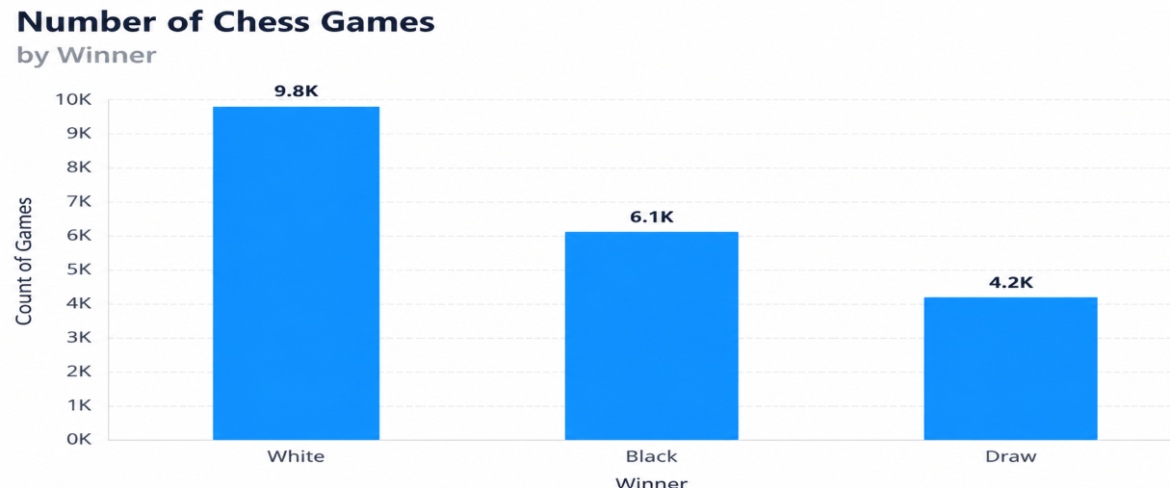

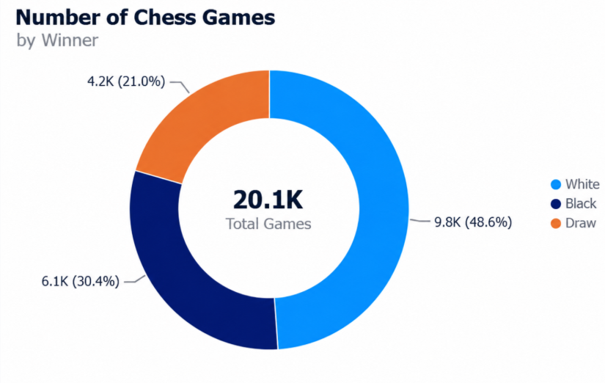

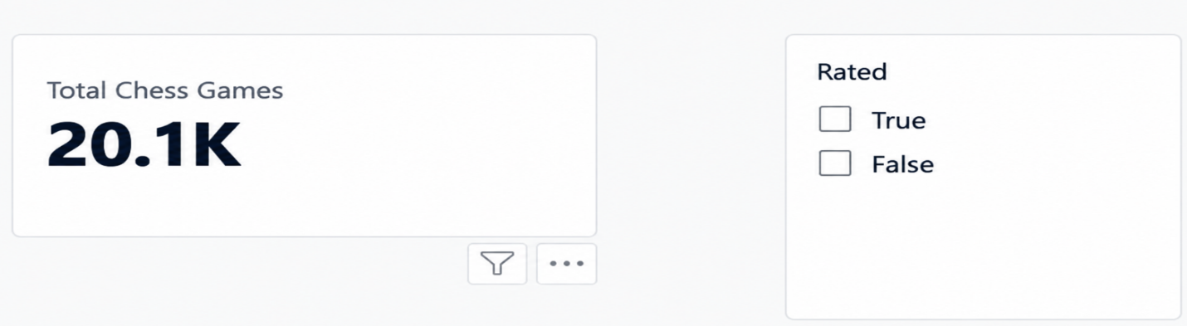

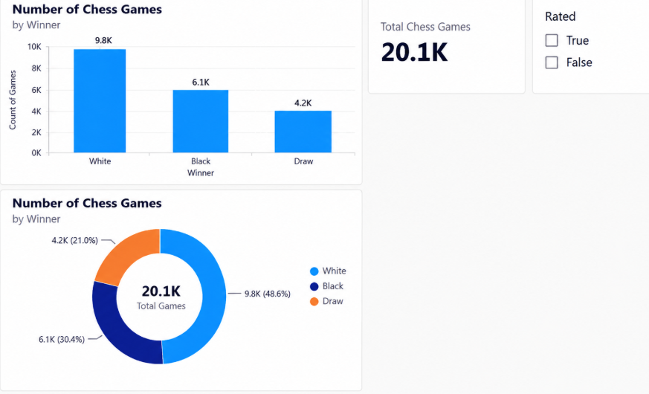

Result:

